Chapter 7, Solution 61.

The current source is transformed as shown below.
4 

+
−
20u(-t) + 40u(t)
0.5 H
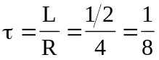, 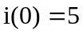, 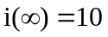
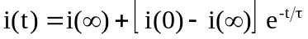

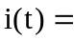 (10 – 5e^{–8t})u(t) A

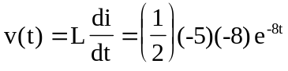

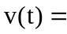 20e^{–8t}u(t) V

